# ADTS – Automated Detectors Test System – Getting Started

## Installation \ Setup

* Unzip the file to a directory of your choice.
* In the \Resources\Databases directory you will find ADTS v001 WithData.sql script. Execute it in SQL Server Management Studio and make sure database ADTS was created successfully.
* In the \Binaries directory you will find ADTS.bat file. Since our system is expected to be called using 3 parameters (User, Environment, Connection String), I created a batch file that can simulate it (in case you want to run it outside of Visual Studio). Open the batch file for edit and modify the connection string. If you are using local installation of SQL Server Express then you don’t need to do anything – the current connection string should work for you. REMEMBER: this system will NOT work by double-clicking the exe file; you MUST double-click the bat file.
* Open the solution in Visual Studio, and make sure you can build it and run it. Note: inside VS you should also change the command line parameters like we did in the above batch file. You do it by going to the ADTS bootstrapper project’s properties, debug tab, and change command line arguments.

## Current Functionality

* Big part of the TreeView functionality was implemented (without really connecting to the database yet or performing any logic as per the Detail Design). The only part working against the database is reading the hierarchy and being able to Edit a folder (and hit Save). So, you could see how to add nodes, delete nodes, cut\copy\past nodes, drag\drop nodes – but writing to the database is still to come.
* Functionality wise, here are some screenshots:

The main explorer module, as it appears inside the framework:

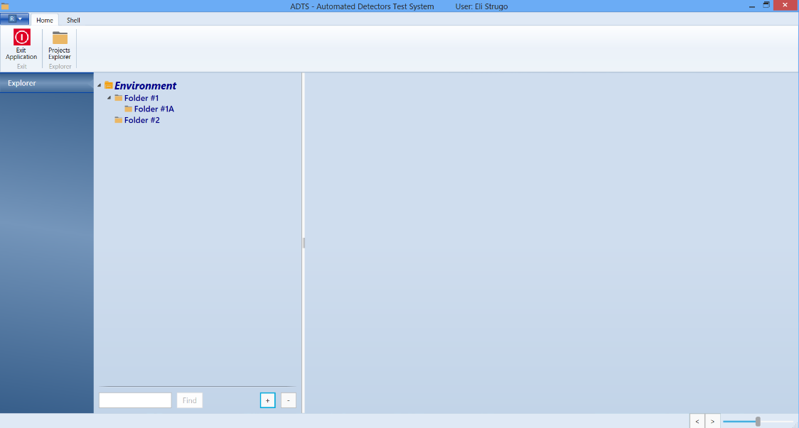

Various functionalities, including ‘simple’ search (based on Name field only), Expand \ Collapse all tree nodes buttons.

Once you stand on a folder, you will see its properties on the right hand side. You can edit those and hit Save.

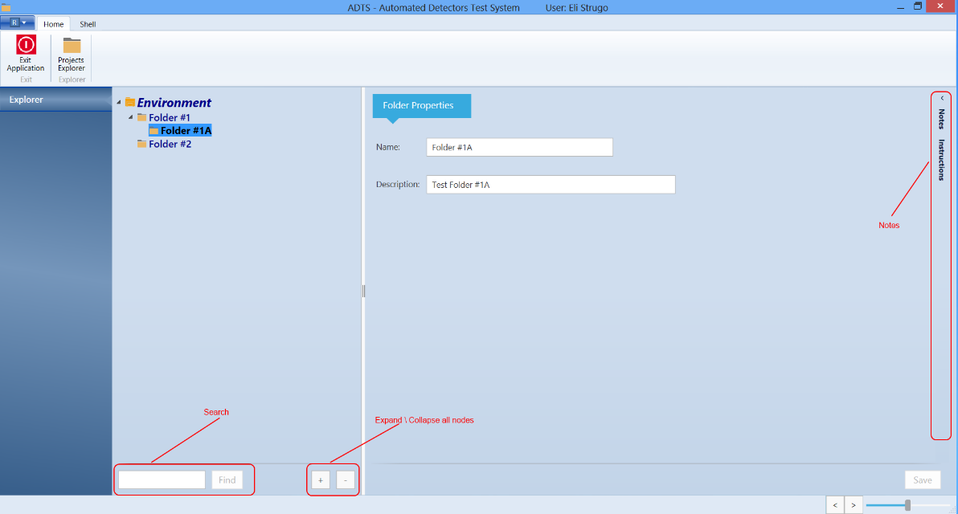

Here you see the notes mechanism. You can activate those by either pressing the vertical bar (in which case they will be opened temporarily on top of the folder’s info); or you can press the small arrow button at the top (in which case the notes will be opened by shrinking the space available for properties).

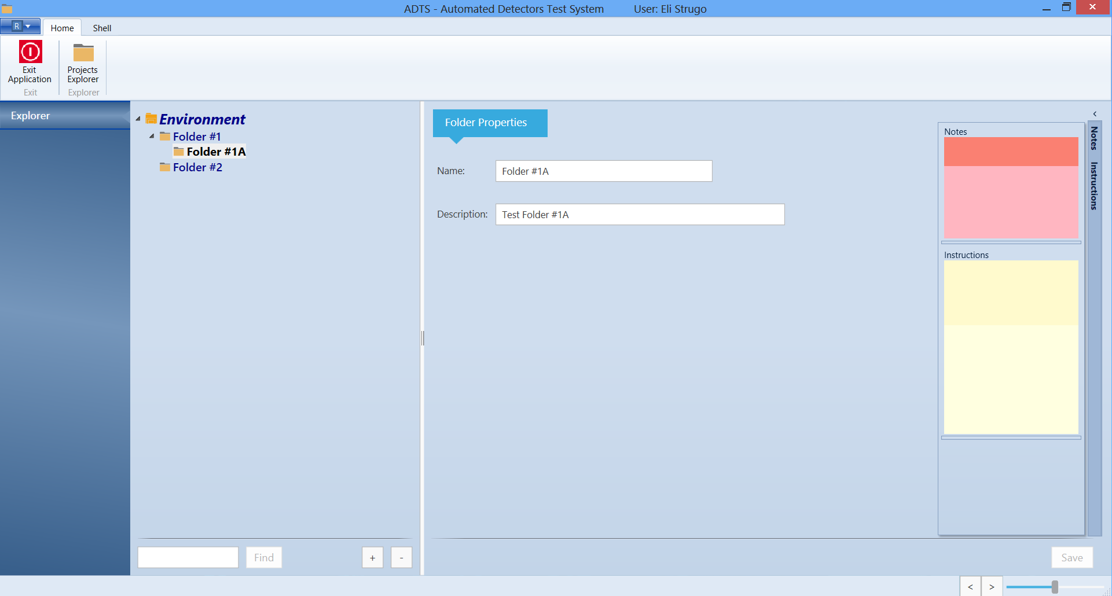

Here we see context-sensitive menu (we will have different menus for every node type):

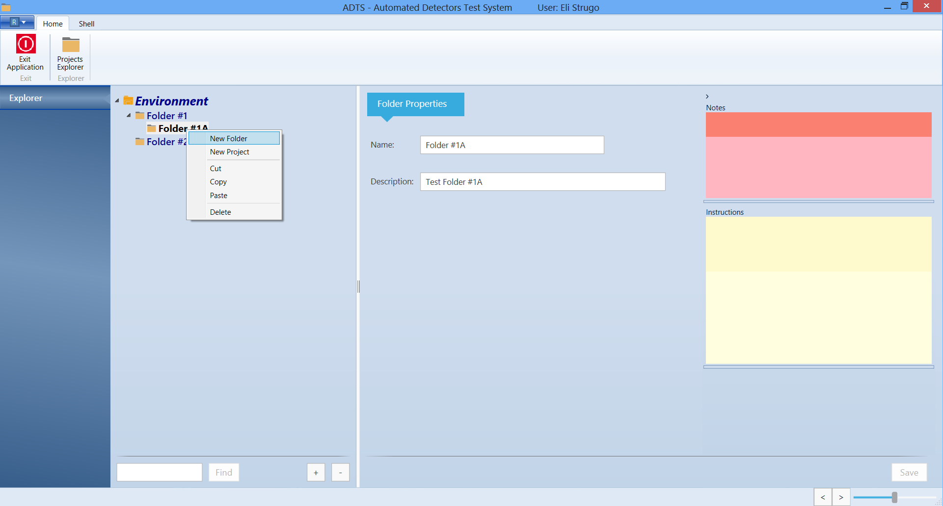

And here we see drag\drop:

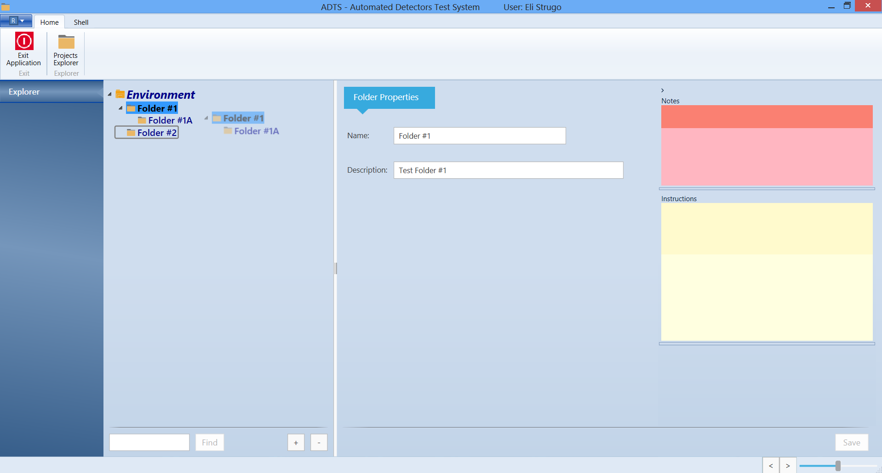

## Next Steps

* Familiarize yourself with the code. We have the sections of the framework (Bootstrapper; UI; VM; Domain), and we have a DLL for every module (so in the future we can have different modules loaded at run time). Most of the work we will be doing from now on will only happen inside the Explorer module.
* Models and Business Logic are placed inside appropriate sections in the main project rather than within the module, as they should be available for all future modules (not specifically the explorer).
* I will continue enhancing all functionality for Folders, and then you can progress with Projects.
* There will be certain User Controls I’ll ask you to develop which are used by the Explorer. These will include:
  + Notes Control.
  + Search Control.
  + TreeView control that displays Content Management data and enables us to drag from there onto a Folder \ Project.
  + The logic of executing content, including the smart copy of content into the local directories.
  + Other functionality as per the DD.